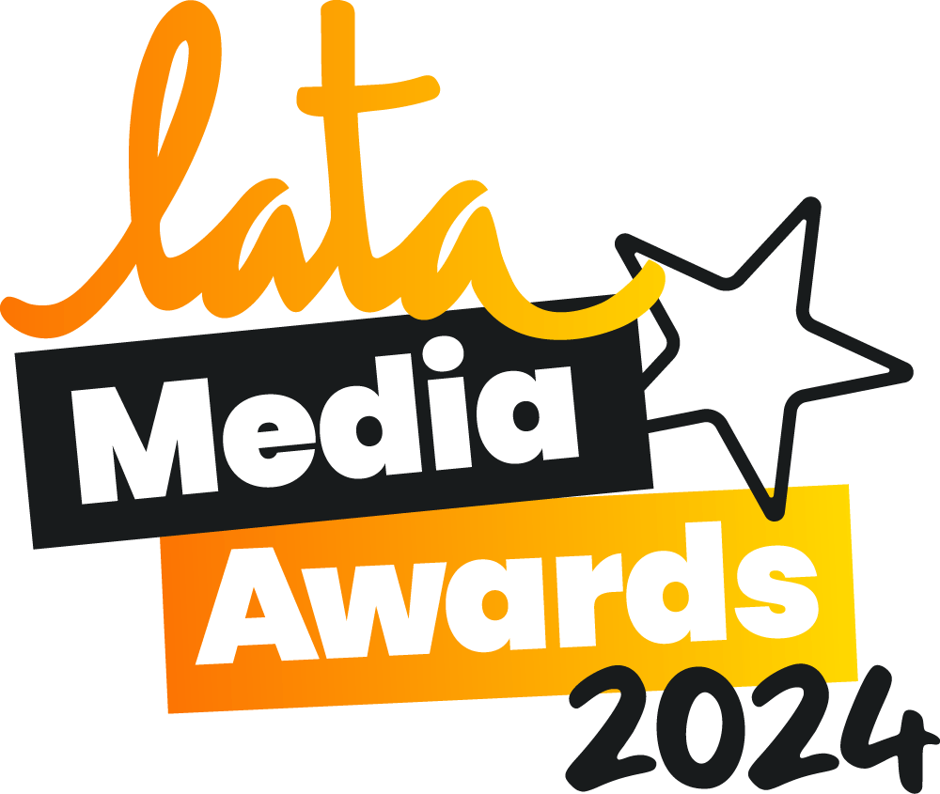

LATA MEDIA AWARDS 2024 – SUBMISSION FORM

Journalist / blogger/ photographer information:

Name __________________________________________________

Address __________________________________________________

Phone __________________________________________________

Email __________________________________________________

If you are submitting an entry on behalf of a journalist, blogger or photographer, please include your contact information below:

Name __________________________________________________

Address __________________________________________________

Phone _______________________________________________________

Email _______________________________________________________

Please do notify the person if you are submitting articles on their behalf (to avoid any duplication)

Entry information:

Category __________________________________________________
Title/headline of article or photo a/o name of blog/ website: __________________________________________________

Publication/ platform in which entry appeared* ______________________________

Date of publication ___________________________________________

Contact person at publication ________________________________________

-ENDS-
For further information, please email latapr@wearelotus.co.uk or contact Kate McWilliams or Jess Cochrane (+ 442079537470)

For more information on the Latin American Travel Association (LATA), please visit https://www.lata.travel/

